Joni R Franks
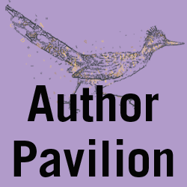
Joni Franks has published her first and very timely children's book inspired by her own life events living in the Rocky Mountains with her Welsh corgi, Sagebrush. The story begins when the little cattle dog is born without a tail. Sage overcomes labeling and bullying with the help of a young woman who hasn't let being a girl stop her from achieving her dreams, Together they disprove the disbelievers and overcome fears that others put upon you just because you look different.

Scheduled events:
Author Pavilion - Children's Books
Author Pavilion - Children (Seats 4)
Sat, Mar 11, 12:15 pm - 2:15 pm
Authors: Tricia Brown, Joni Franks, Betty Fulcomer, Edward Leven, Holly Redfern, Dianne White

Book:
Corky Tails Tales of a Tailless Dog Named Sagebrush
Children / Teens
Xlibris
November 2016
ISBN 9781524558017
The author will make this book available for sale at the Author Pavilion during the Festival.

